Result of training “CatBoostClassification” model
- Reference for using CatBoostClassifier + SHAP as optimal model for transcriptomic data
(cite: Shi, S., Pan, X., Zhang, L., Wang, X., Zhuang, Y., Lin, X., Shi, S., Zheng, J., & Lin, W. (2022). An application based on bioinformatics and machine learning for risk prediction of sepsis at first clinical presentation using transcriptomic data. Frontiers in genetics, 13, 979529. https://doi.org/10.3389/fgene.2022.979529)

== the best model ==
- Load preprocessed dataset
Total dataset = (199, 56685)
# 1=squamous cell cancer, 2=AC unspecified, 3=Large cell/ NOS
Class Distribution: {1: 67, 2: 108, 3: 24}
- Set up train/test sets
X_train, X_test, y_train, y_test = train_test_split(gene_data, labels, test_size=0.2, random_state=42, stratify=labels, shuffle=True)
Train set = (159, 56685)
Test set = (40, 56685)
==Original training set==
Training Class Distribution: {1: 54, 2: 86, 3: 19}
Testing Class Distribution: {1: 13, 2: 22, 3: 5}
- Decompose by using PCA (sklearn.decomposition)
Configure the number of components = 25 (variance ratio = 0.965224)
num_components = 25

# Apply PCA
pca = PCA(n_components=num_components)
X_train_pca = pca.fit_transform(X_train)
X_test_pca = pca.transform(X_test)
Train set of PCA = (159, 25)
Test set of PCA = (40,25)
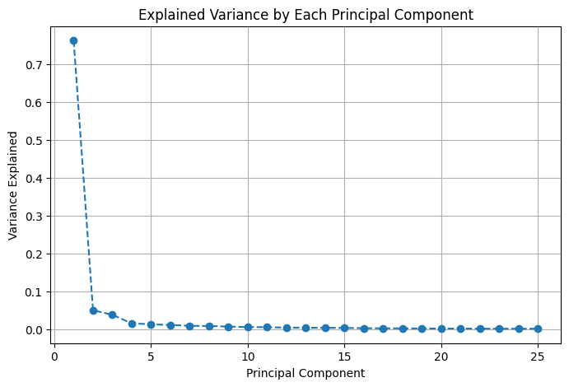
- Data imbalance handling
Calculate class weights (sklearn.utils.class_weight)
classes = np.unique(y_train)
class_weights = compute_class_weight(class_weight='balanced', classes=classes, y=y_train)
Class weights: {1: 0.9814814814814815, 2: 0.6162790697674418, 3: 2.789473684210526}
- Train the CatBoostClassification model
Tuning the hyperparams using GridsearchCV (sklearn.model_selection) + StratifiedKFold (sklearn.model_selection)
# Define parameter grid
param_grid = {
'depth': [3, 4, 5],
'learning_rate': [0.01, 0.03, 0.05],
'l2_leaf_reg': [5, 7, 10],
'iterations': [100, 200, 300],
'bootstrap_type': ['MVS','Bayesian'],
# 'subsample': [0.8, 1.0],
}

# Create model and GridSearchCV
cb = CatBoostClassifier(random_state=42, verbose=0, class_weights=class_weights_dict)
# cb = CatBoostClassifier(random_state=42, verbose=0)

# Use balanced accuracy as the evaluation metric
scorer = make_scorer(balanced_accuracy_score)

# Perform GridSearch with Stratified K-Fold Cross-Validation
kf = StratifiedKFold(n_splits=5, shuffle=True, random_state=42)

grid_search = GridSearchCV(
cb,
param_grid,
cv=kf,
scoring=scorer,
n_jobs=-1
)

# Fit GridSearchCV
grid_search.fit(X_train_pca, y_train)

# Get best parameters and train final model
best_params = grid_search.best_params_
print("Best Parameters:", best_params)
Best Parameters: {'bootstrap_type': 'Bayesian', 'depth': 3, 'iterations': 300, 'l2_leaf_reg': 5, 'learning_rate': 0.05}
# Train with best parameters
best_model = CatBoostClassifier(**best_params, random_state=42, verbose=0,
eval_metric='MultiClass',
early_stopping_rounds=20,
class_weights=class_weights_dict
)
best_model.fit(X_train_pca, y_train, eval_set=(X_test_pca, y_test),plot=False)

# Save the model to a file (e.g., "best_model.cbm")
best_model.save_model("best_model.cbm", format="cbm")
display the decision tree from the CatBoost
from catboost import Pool
# # Visualize a specific tree
best_model.plot_tree(tree_idx=0, pool=Pool(X_train_pca, y_train, feature_names=[f'PC{i+1}' for i in range(X_train_pca.shape[1])]))
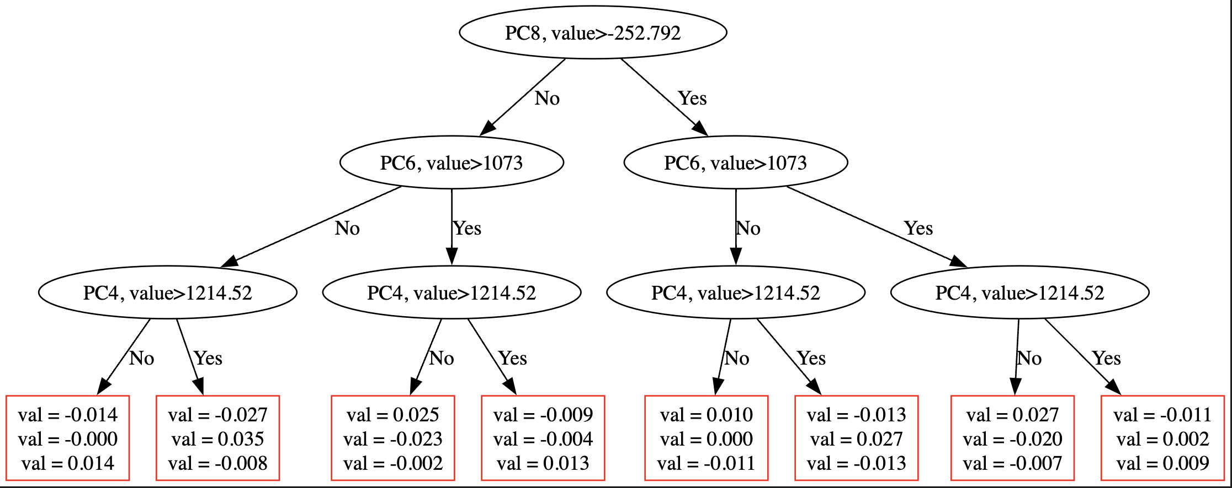
- Evaluate the best model
Using balanced_acc_score (sklearn.matrics) for imbalanced dataset
# Accuracy
bal_acc_train = balanced_accuracy_score(y_train, y_pred_train)
bal_acc_test = balanced_accuracy_score(y_test, y_pred_test)
Balanced Accuracy Train = 0.9489
Balanced Accuracy Test = 0.6939
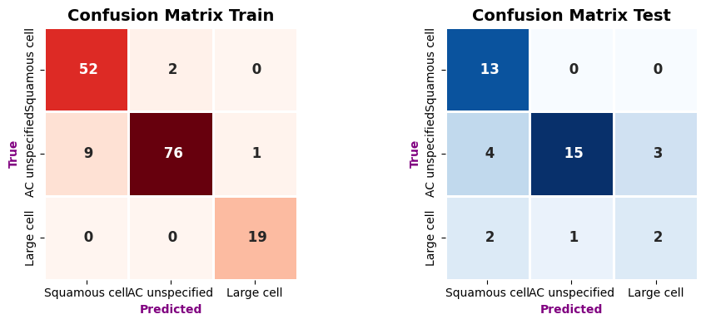
- Feature importance
Within CatBoost feature
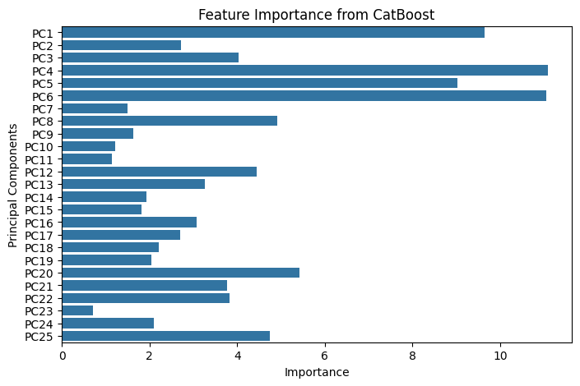
# Choose the top genes for specific PCs
selected_pcs = ['PC1', 'PC5', 'PC4', 'PC6']
top_n = 10

# Extract component loadings (contributions of genes to each component)
pca_components = pca.fit(X_train)
components_df = pd.DataFrame(pca_components.components_, columns=gene_data.columns)
components_df.index = [f'PC{i+1}' for i in range(num_components)]
components_df.head()

# Extract top contributing genes for each PC
top_genes_df = pd.DataFrame(0, index=X_train.columns, columns=selected_pcs)
for pc in selected_pcs:
top_genes = components_df.loc[pc].abs().nlargest(top_n).index
top_genes_df.loc[top_genes, pc] = 1

# Plot heatmap
plt.figure(figsize=(8, 8))
sns.heatmap(top_genes_df.loc[top_genes_df.sum(axis=1) > 0], cmap='Blues', annot=True)
plt.title('Top Gene Overlap Across PCs')
plt.xlabel('Principal Components')
plt.ylabel('Genes')
plt.show()
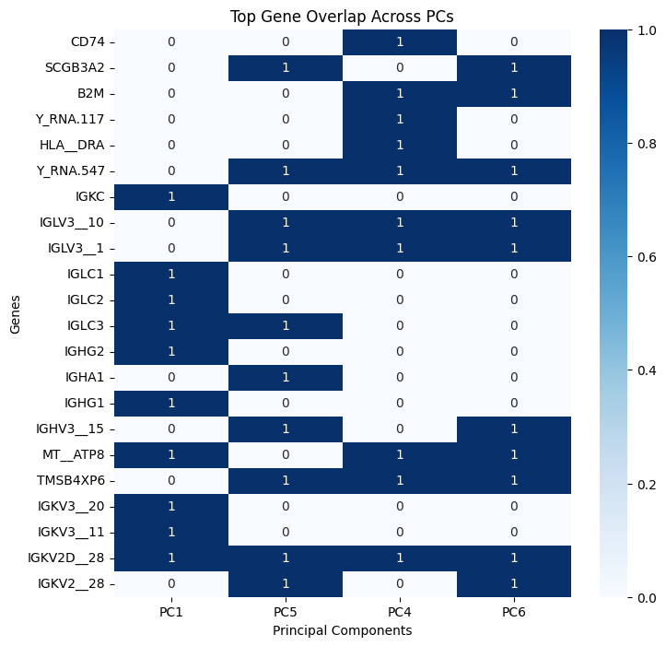
Within SHAP
gene_names = gene_data.columns

# SHAP Interpretation
explainer = shap.TreeExplainer(best_model)
shap_values = explainer(X_train_pca)

# Visualize SHAP values for the top 3 PCA components
shap.summary_plot(shap_values, X_train_pca, feature_names=[f'PC{i+1}' for i in range(X_train_pca.shape[1])])

# Calculate mean absolute SHAP values for each PCA component
mean_abs_shap = np.abs(shap_values.values).mean(axis=(0, 2))

top_features_indices = np.argsort(mean_abs_shap)[-3:][::-1]
print("Top 3 Biomarker Candidates (PCA Components) in Order of Importance:", top_features_indices)
for i, idx in enumerate(top_features_indices):
print(f"PC{idx+1}: Mean SHAP Value = {mean_abs_shap[idx]:.4f}")
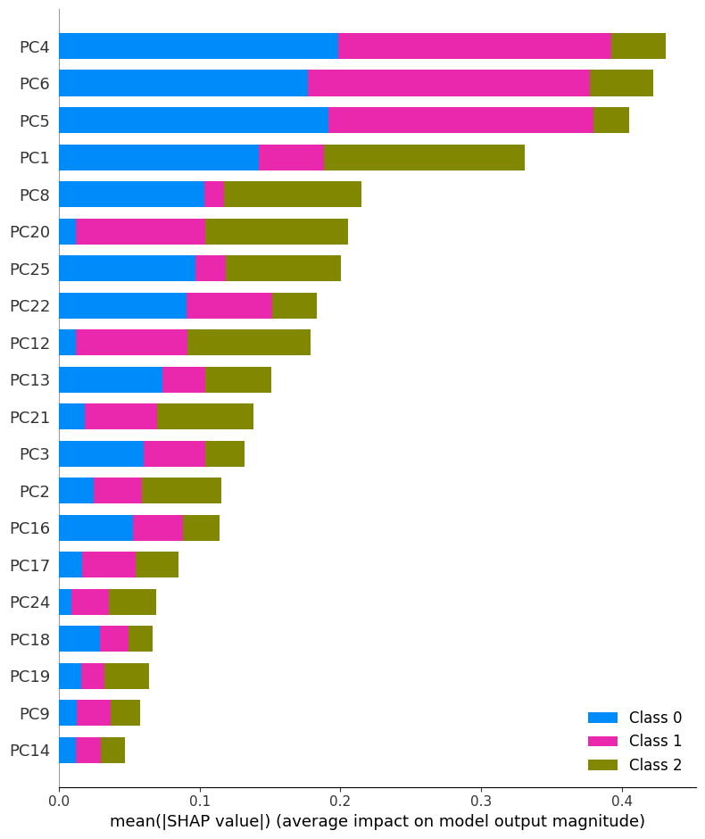
Top 3 Biomarker Candidates (PCA Components) in Order of Importance: [3 5 4]
PC4: Mean SHAP Value = 0.1437
PC6: Mean SHAP Value = 0.1407
PC5: Mean SHAP Value = 0.1351
# SHAP values for each class
genes_set = []
for class_idx in range(shap_values.values.shape[2]):
print(f"\nClass {class_idx+1} Top Biomarkers:")
shap_values_class = np.abs(shap_values.values[:, :, class_idx]).mean(axis=0)
top_genes_idx = np.argsort(shap_values_class)[-10:][::-1] # Top 10 genes
top_genes = [gene_names[i] for i in top_genes_idx]
genes_set.append(set(top_genes))
print(f"Top Genes: {top_genes}")

# Ogcogene
oncogenes = ["EGFR", "KRAS", "MET", "LKB1", "BRAF", "PIK3CA", "ALK", "RET", "ROS1"]
print(f"Containing Oncogenes: {([gene for gene in top_genes if gene in oncogenes])}")
Class 1 Top Biomarkers:
Top Genes: ['SCYL3', 'C1orf112', 'FGR', 'TSPAN6', 'FUCA2', 'HS3ST1', 'BAD', 'LAS1L', 'DPM1', 'CFTR']
Containing Oncogenes: []

Class 2 Top Biomarkers:
Top Genes: ['FGR', 'SCYL3', 'C1orf112', 'RAD52', 'NIPAL3', 'BAD', 'MYH16', 'TSPAN6', 'DPM1', 'ANKIB1']
Containing Oncogenes: []

Class 3 Top Biomarkers:
Top Genes: ['TSPAN6', 'RAD52', 'FUCA2', 'NIPAL3', 'HS3ST1', 'MYH16', 'TNMD', 'LAS1L', 'FGR', 'SCYL3']
Containing Oncogenes: []
from matplotlib_venn import venn3

venn3(genes_set, ('Class 1', 'Class 2', 'Class 3'))
plt.title("Overlap of Top Biomarker Genes Among Classes")
plt.show()

# Find non-overlapping genes for each class
unique_to_class_0 = genes_set[0] - genes_set[1] - genes_set[2]
unique_to_class_1 = genes_set[1] - genes_set[0] - genes_set[2]
unique_to_class_2 = genes_set[2] - genes_set[0] - genes_set[1]

print("Unique to Class 0:", unique_to_class_0)
print("Unique to Class 1:", unique_to_class_1)
print("Unique to Class 2:", unique_to_class_2)
print("Intersection of All Classes:", genes_set[0] & genes_set[1] & genes_set[2])
print("Set of All Genes:", genes_set[0] | genes_set[1] | genes_set[2])
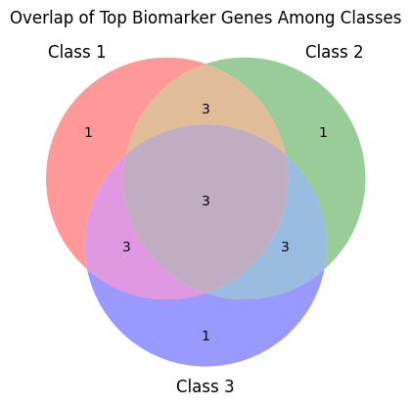
1=squamous cell cancer, 2=AC unspecified, 3=Large cell/ NOS

Unique to Class 1 (Squamous cell cancer): {'CFTR'}
Unique to Class 2 (AC unspecified): {'ANKIB1'}
Unique to Class 3 (Large cell): {'TNMD'}
Intersection of All Classes: {'TSPAN6', 'FGR', 'SCYL3'}
Set of All Genes: {'SCYL3', 'NIPAL3', 'HS3ST1', 'CFTR', 'C1orf112', 'BAD', 'FGR', 'MYH16', 'DPM1', 'TNMD', 'FUCA2', 'TSPAN6', 'RAD52', 'LAS1L', 'ANKIB1'}
- Interpretation
TNMD(Tenomodulin),
This gene encodes a protein that is related to chondromodulin-I, which is a cartilage-specific glycoprotein that functions to stimulate chondrocyte growth and to inhibit tube formation of endothelial cells. This protein is also an angiogenesis inhibitor. Genetic variation in this gene is associated with a risk for type 2 diabetes, central obesity and serum levels of systemic immune mediators in a body size-dependent manner.
(cite: https://www.ncbi.nlm.nih.gov/gene/64102)

CFTR (Cystic Fibrosis Transmembrane Conductance Regulator),
Germline mutations in the gene encoding CFTR cause recessive cystic fibrosis (CF). Suppression of CFTR promotes epithelial-mesenchymal transition (EMT) and metastasis providing mechanistic basis for the role of CFTR in lung cancer.
(cite: Li, J., Zhang, J.T., Jiang, X., Shi, X., Shen, J., Feng, F. ... Chan, H.C. (2015). The cystic fibrosis transmembrane conductance regulator as a biomarker in non-small cell lung cancer. International Journal of Oncology, 46, 2107-2115. https://doi.org/10.3892/ijo.2015.2921)

ANKIB1 (Ankyrin Repeat and IBR Domain Containing 1)
Two multi-omics-based core genes (CNTN4 and RFTN1) could become potential therapeutic targets for LUAD. ANKIB1 is one of the top ten most significant correlations between RFTN1 gene expression and SNVs.
(cite: Zhao, Y., Gao, Y., Xu, X., Zhou, J., & Wang, H. (2021). Multi-omics analysis of genomics, epigenomics and transcriptomics for molecular subtypes and core genes for lung adenocarcinoma. BMC cancer, 21(1), 257. https://doi.org/10.1186/s12885-021-07888-4)
- Compare the result
For LUAD and LUSC biomarker
(cite: Chen, J.W., Dhahbi, J. Lung adenocarcinoma and lung squamous cell carcinoma cancer classification, biomarker identification, and gene expression analysis using overlapping feature selection methods. Sci Rep 11, 13323 (2021). https://doi.org/10.1038/s41598-021-92725-8)

For NSCLC biomarker in general
Gene Expression Profiling Interactive Analysis dataset based on The Cancer Genome Atlas and Genotype-Tissue Expression
http://gepia.cancer-pku.cn/index.html
(cite: Wang, F., Su, Q. & Li, C. Identidication of novel biomarkers in non-small cell lung cancer using machine learning. Sci Rep 12, 16693 (2022). https://doi.org/10.1038/s41598-022-21050-5)

== PCA optimal component Experiment ==
Train = 0.8, test = 0.2 (159,40)
cb = CatBoostClassifier(
random_state=42,
# class_weights=class_weights_dict, # comment out if using SMOTE
l2_leaf_reg=7,
depth=4,
learning_rate=0.05,
# bootstrap_type='Bayesian',
bootstrap_type='Bernoulli',
subsample=0.8,
early_stopping_rounds=50,
verbose=0
)

Preprocessing | Hyper-params | Train_acc | Test_acc | Confusion matrix
- PCA(n_components=120), ratio = 0.9986778860686507 | - Classweights  - Boostrap_type = ‘Bayesian’ | 1.00 | 0.6107
- PCA(n_components=120), ratio = 0.9986778860686507 | - Classweights  - Boostrap_type = ‘Bernoulli’  - Subsample=0.8 | 1.00 | 0.5956 | 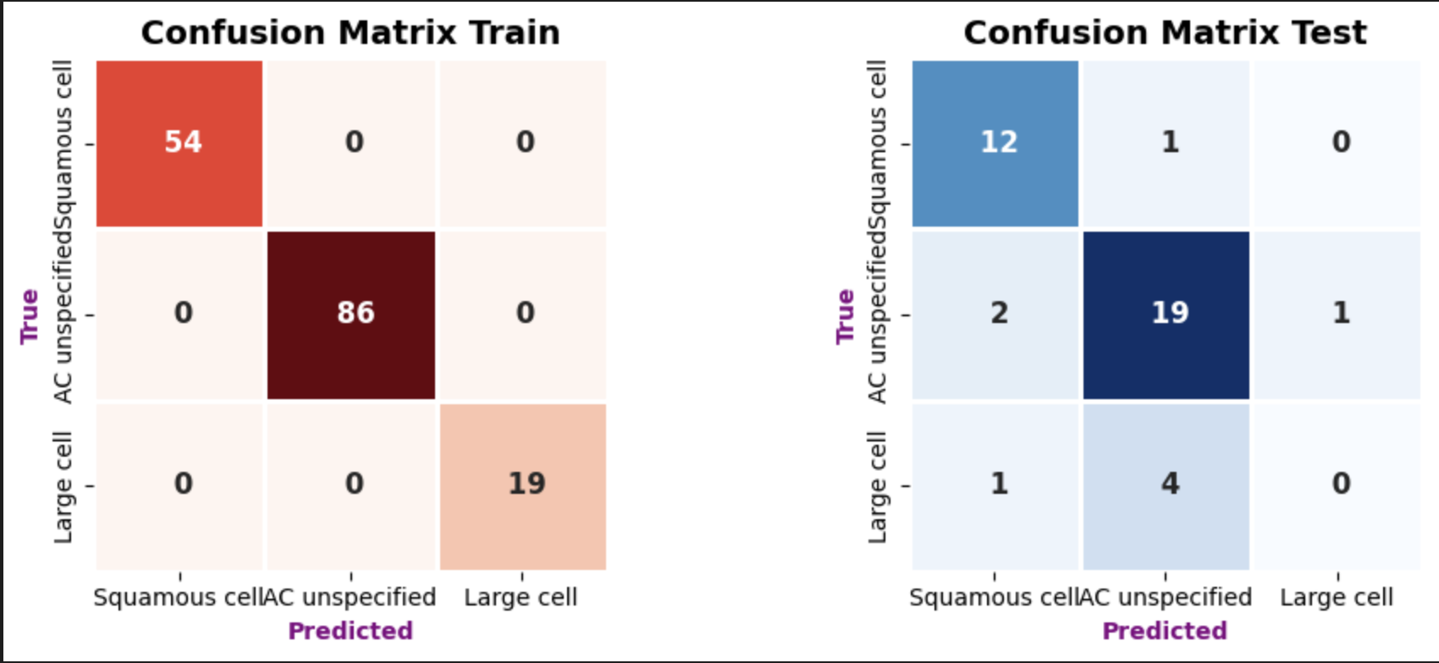
- PCA(n_components=120), ratio = 0.9986778860686507  - SMOTE(random=42) | - Boostrap_type = ‘Bayesian’ | 1.00 | 0.6259
- PCA(n_components=120), ratio = 0.9986778860686507  SMOTE(random=42) | - Boostrap_type = ‘Bernoulli’  - Subsample=0.8 | 1.00 | 0.5956 | 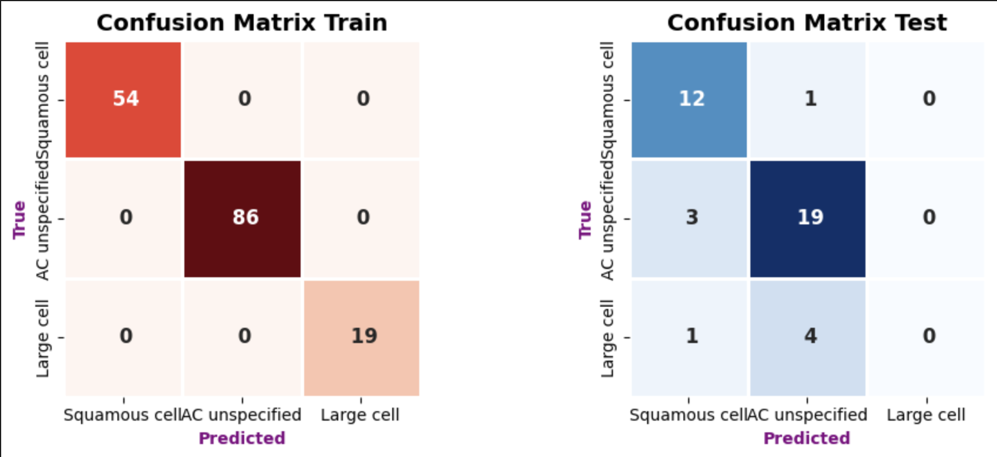
- PCA(n_components=120), ratio = 0.9986778860686507  - Undersampling(random=42) | - Boostrap_type = ‘Bayesian’ | 0.8005 | 0.5503 | 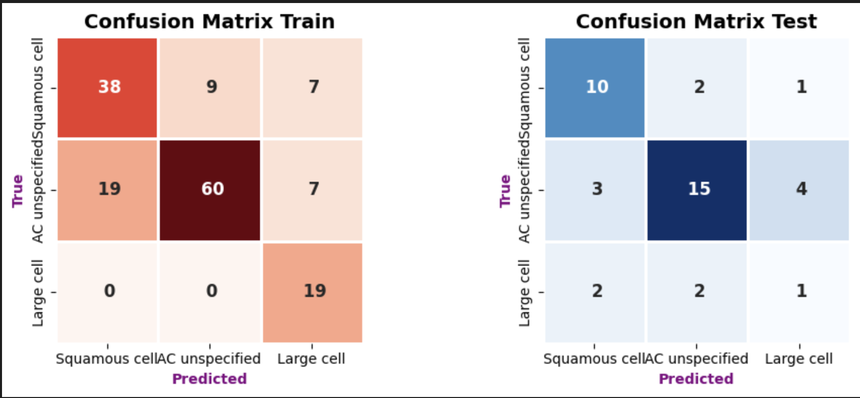
- PCA(n_components=120), ratio = 0.9986778860686507  - Undersampling(random=42) | - Boostrap_type = ‘Bernoulli’  - Subsample=0.8 | 0.7989 | 0.6322 | 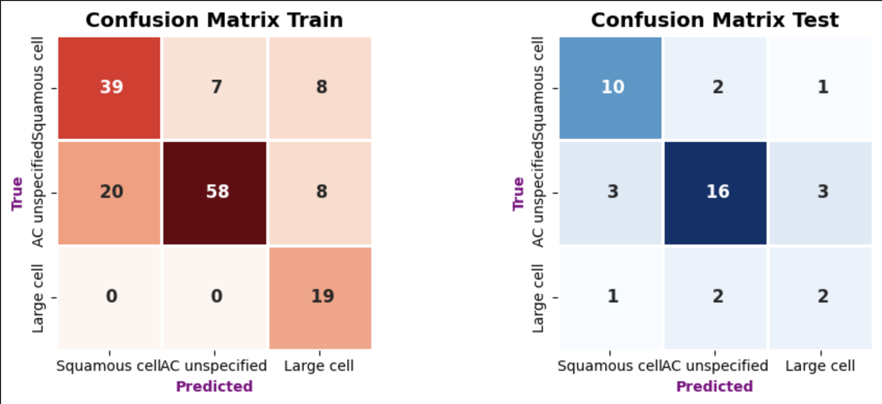
- PCA(n_components=20), ratio = 0.956643  - SMOTE(random=42) | - Best Parameters: {'bootstrap_type': 'Bernoulli', 'depth': 3, 'iterations': 300, 'l2_leaf_reg': 5, 'learning_rate': 0.05, 'subsample': 1.0} | 0.8980 | 0.5455 | 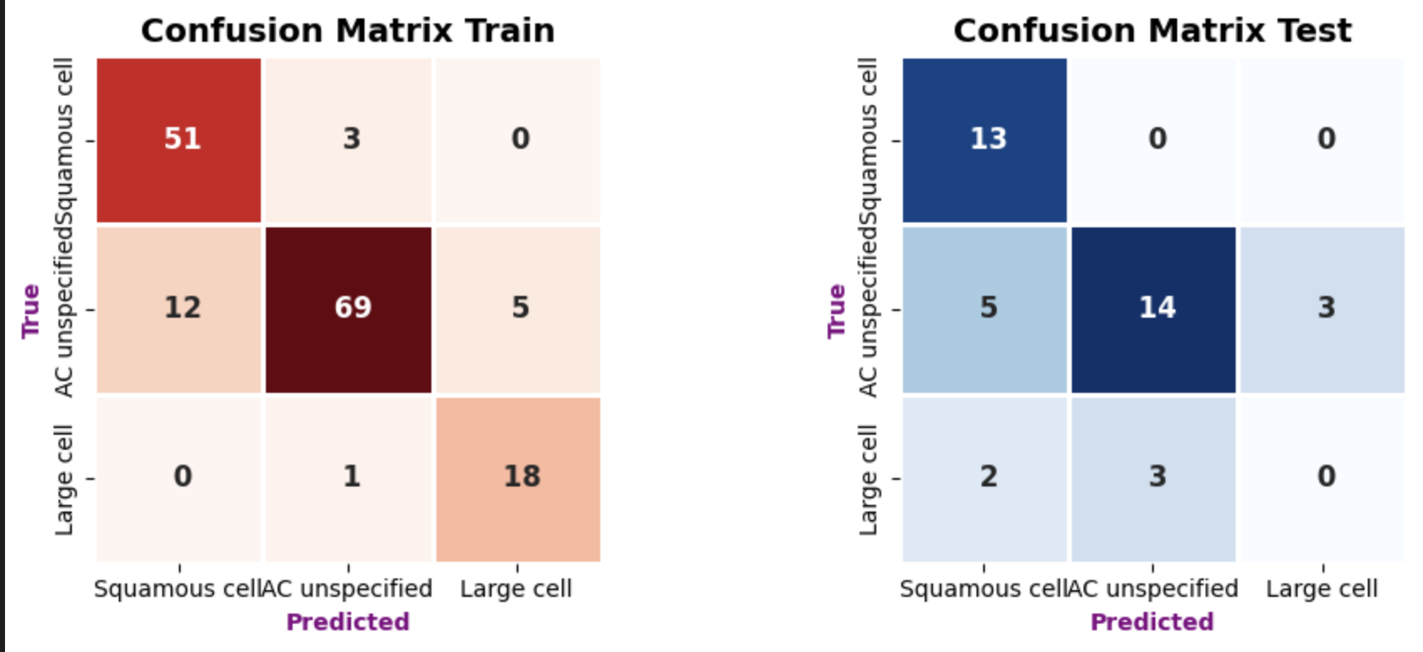
- PCA(n_components=20), ratio = 0.956643  - Undersampling(random=42) | - Best Parameters: {'bootstrap_type': 'Bernoulli', 'depth': 5, 'iterations': 100, 'l2_leaf_reg': 7, 'learning_rate': 0.01, 'subsample': 1.0} | 0.8575 | 0.5818 | 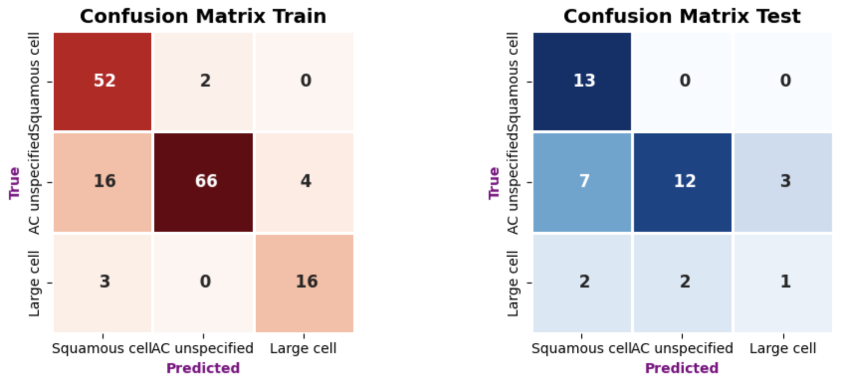
- PCA(n_components=10), ratio = 0.9221418 | - Class weight  - Best Parameters: {'bootstrap_type': 'MVS', 'depth': 3, 'iterations': 300, 'l2_leaf_reg': 5, 'learning_rate': 0.05} | 0.8663 | 0.5152 | 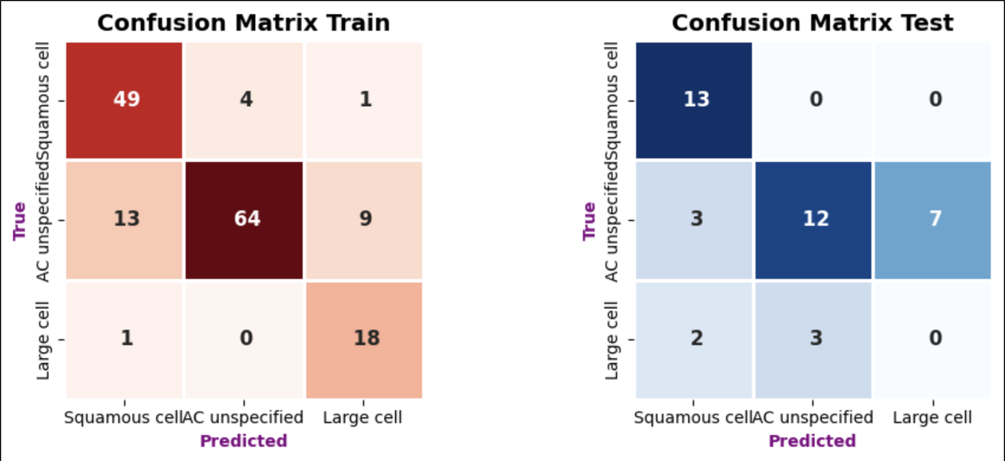
- PCA(n_components=15), ratio = 0.944153 | - Class weight  - Best Parameters: {'bootstrap_type': 'Bayesian', 'depth': 5, 'iterations': 300, 'l2_leaf_reg': 5, 'learning_rate': 0.05} | 0.9450 | 0.5606 | 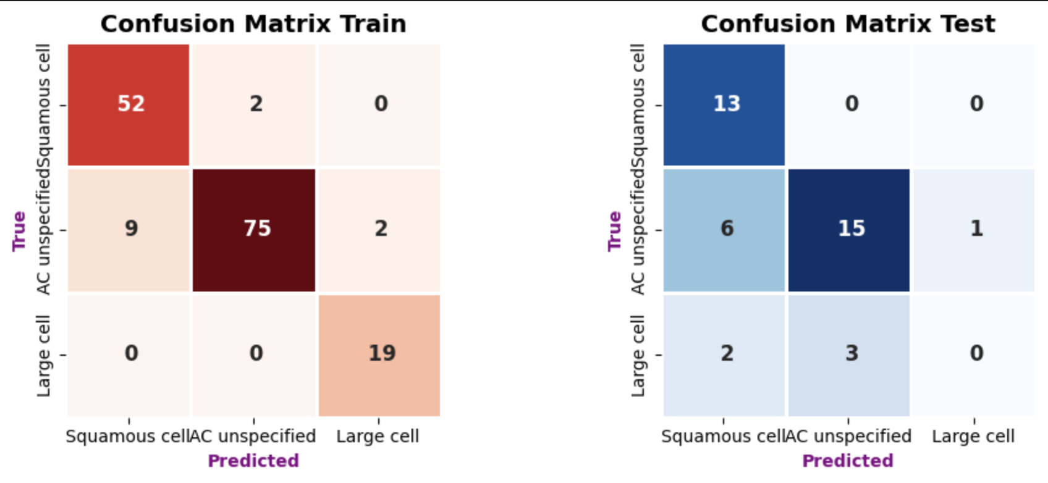
- PCA(n_components=20), ratio = 0.956643 | - Class weight  - Best Parameters: {'bootstrap_type': 'Bayesian', 'depth': 4, 'iterations': 100, 'l2_leaf_reg': 10, 'learning_rate': 0.05} | 0.8666 | 0.6333 | 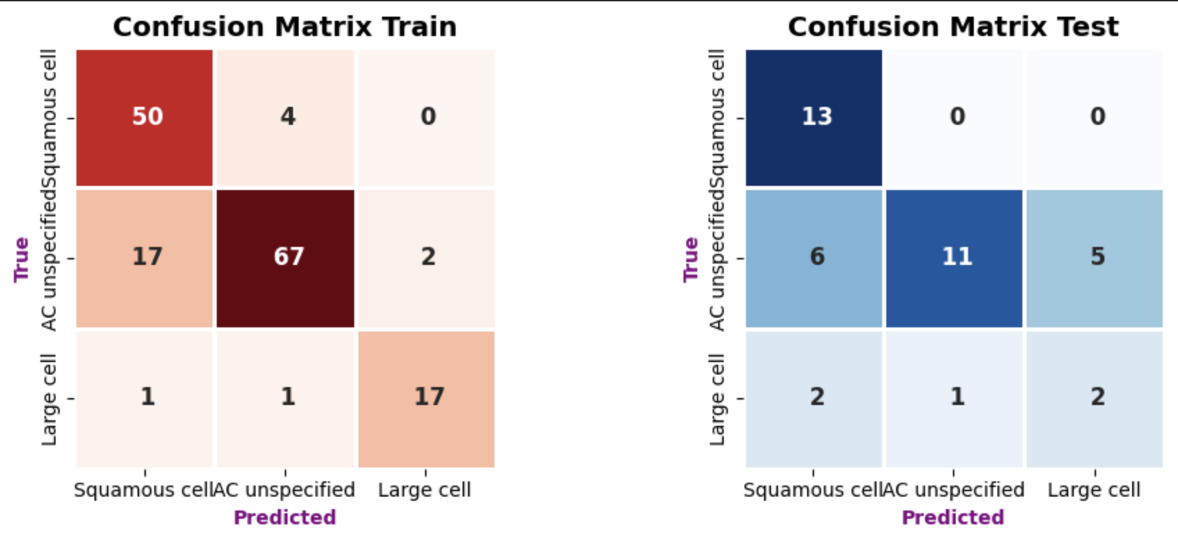
- PCA(n_components=25), ratio = 0.965226177 | - Class weight  - Best Parameters: {'bootstrap_type': 'Bayesian', 'depth': 3, 'iterations': 300, 'l2_leaf_reg': 5, 'learning_rate': 0.05} | 0.9427 | 0.6939 | 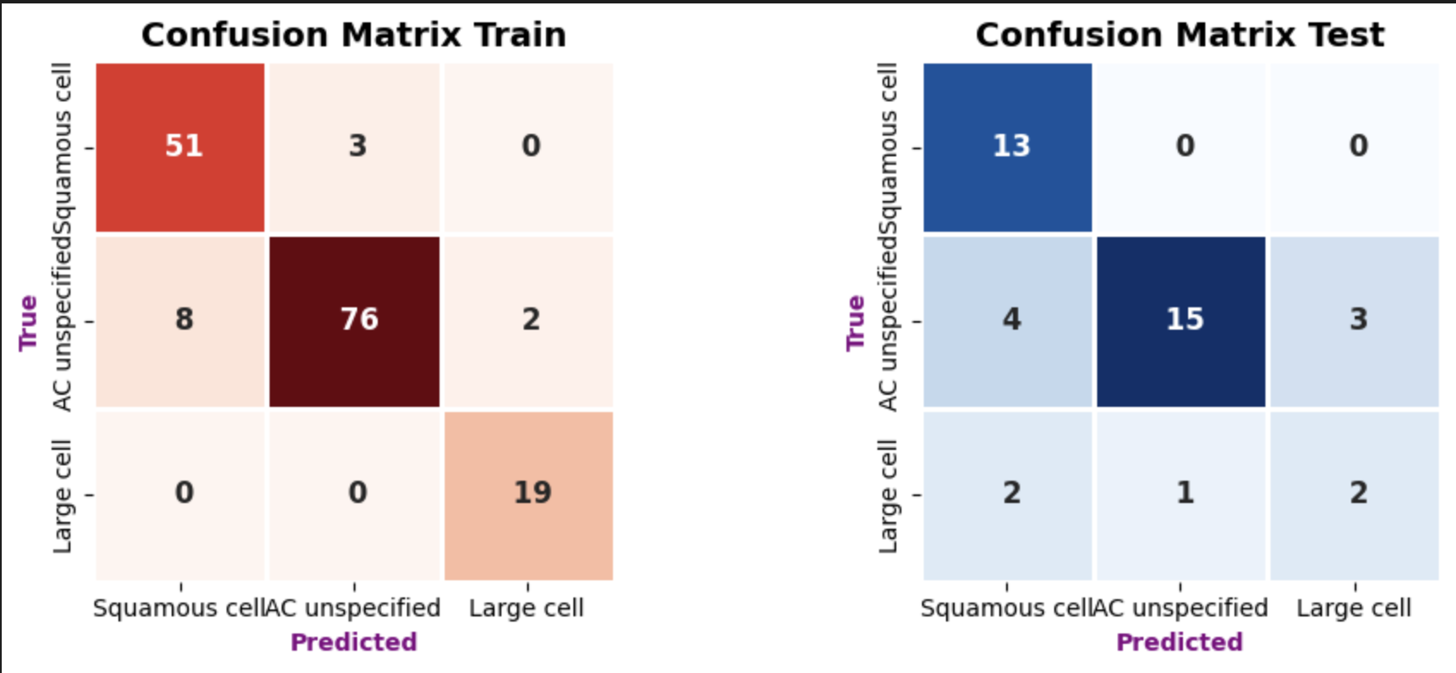
- PCA(n_components=30), ratio = 0.971756 | - Class weight  - Best Parameters: {'bootstrap_type': 'MVS', 'depth': 5, 'iterations': 300, 'l2_leaf_reg': 7, 'learning_rate': 0.05} | 0.9806 | 0.5865 | 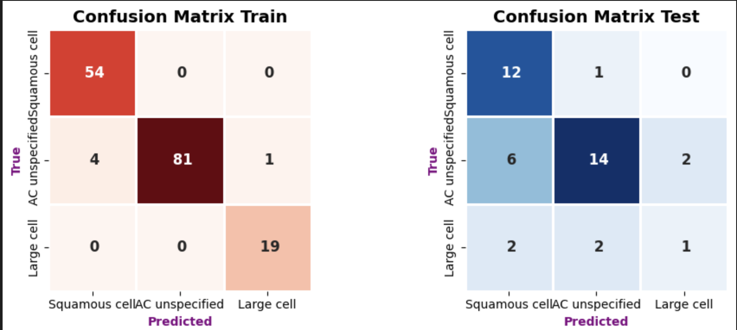
- PCA(n_components=40), ratio = 0.9808289 | - Class weight  - Best Parameters: {'bootstrap_type': 'Bayesian', 'depth': 4, 'iterations': 300, 'l2_leaf_reg': 7, 'learning_rate': 0.05} | 0.9884 | 0.5501 | 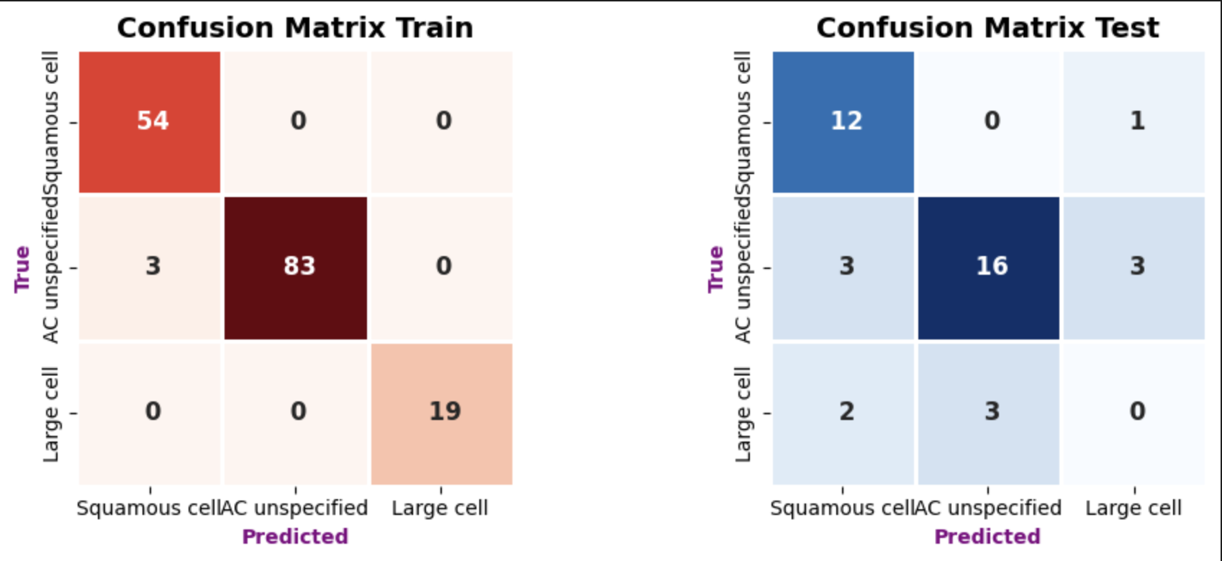
- PCA(n_components=7), ratio = 0.9002205 | - Classweights  - Best Parameters: {'bootstrap_type': 'Bernoulli', 'depth': 5, 'iterations': 100, 'l2_leaf_reg': 5, 'learning_rate': 0.05, 'subsample': 1.0} | 0.8939 | 0.5152 | 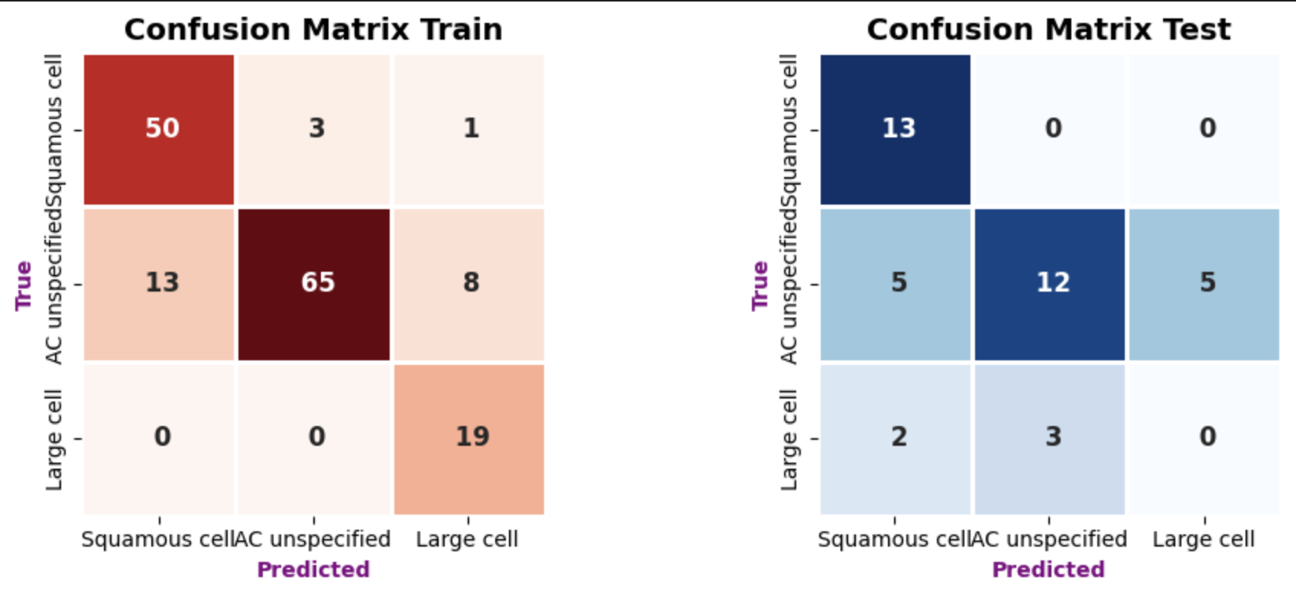
- PCA(n_components=7), ratio = 0.9002205

== SMOTE ==
# Define parameter grid
param_grid = {
'depth': [3, 4, 5],
'learning_rate': [0.01, 0.03, 0.05],
'l2_leaf_reg': [5, 7, 10],
'iterations': [100, 200, 300],
'bootstrap_type': ['Bernoulli'],
'subsample': [0.8, 1.0],
}

# Create model and GridSearchCV
cb = CatBoostClassifier(random_state=42, verbose=0)

# Use balanced accuracy as the evaluation metric
scorer = make_scorer(balanced_accuracy_score)

grid_search = GridSearchCV(
cb,
param_grid,
cv=5,
scoring=scorer,
n_jobs=-1
)
Best Parameters: {'bootstrap_type': 'Bernoulli', 'depth': 5, 'iterations': 300, 'l2_leaf_reg': 5, 'learning_rate': 0.05, 'subsample': 0.8}
Balanced Accuracy Train = 0.9760
Balanced Accuracy Test = 0.5865
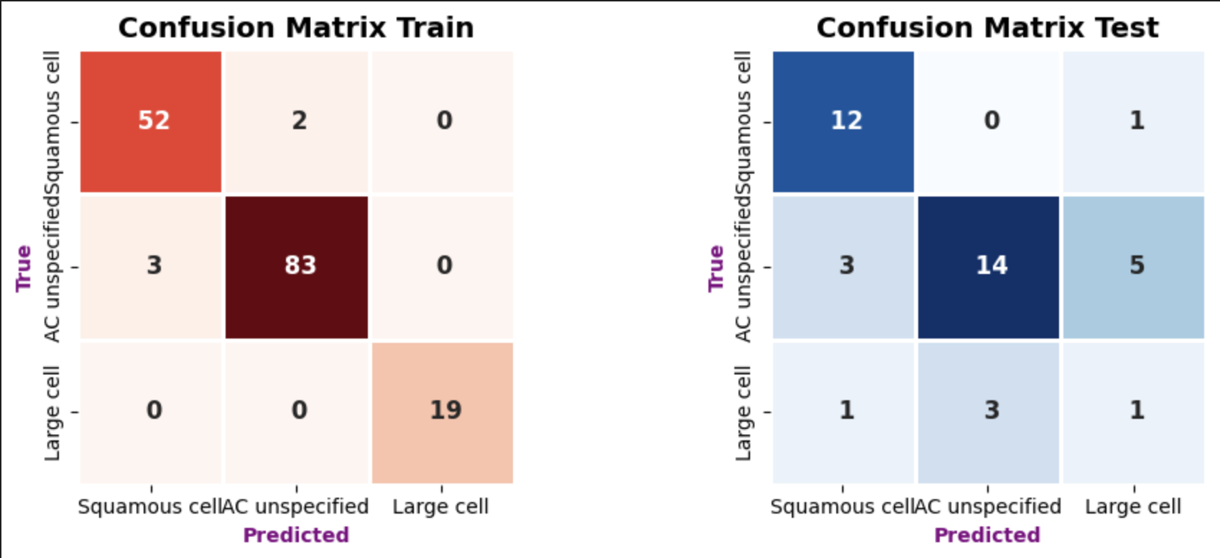

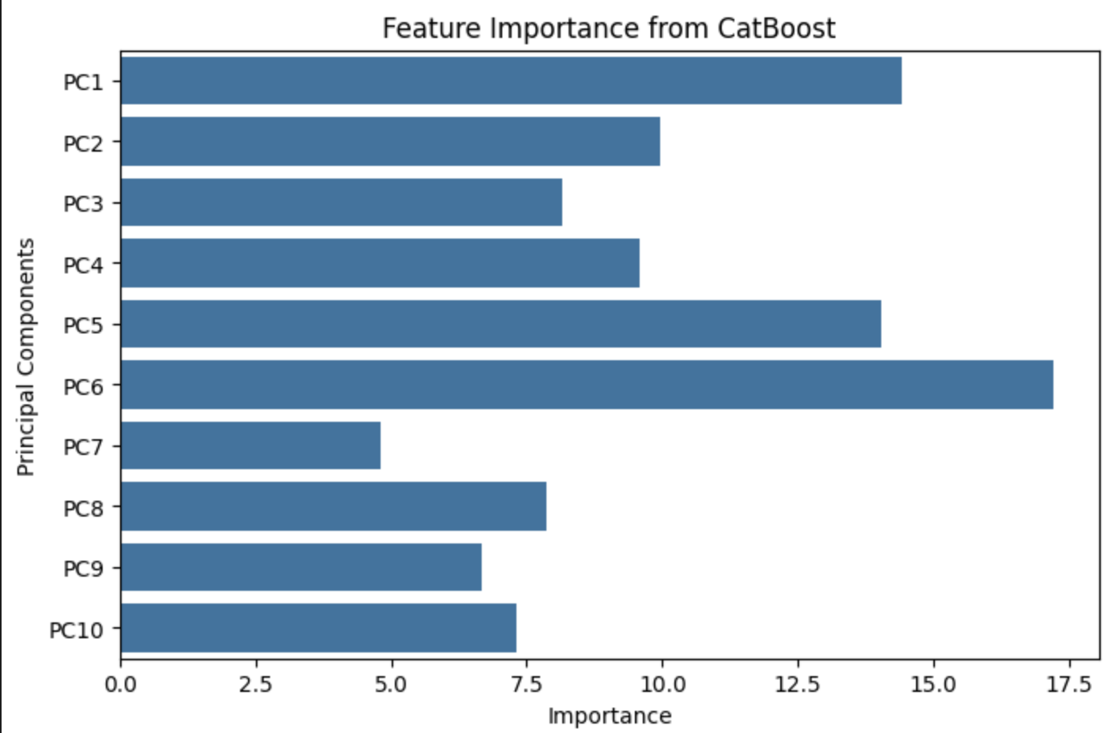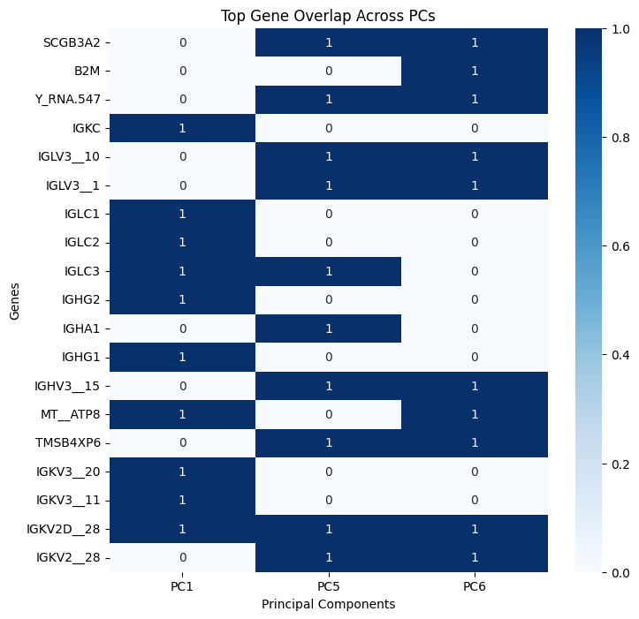
Preprocessing | Hyper-params | Train_acc | Test_acc | Confusion matrix
- PCA(n_components=10), ratio = 0.9221418  - SMOTE (random=42), train 159 -> 258 | Best Parameters: {'bootstrap_type': 'Bernoulli', 'depth': 4, 'iterations': 300, 'l2_leaf_reg': 5, 'learning_rate': 0.05, 'subsample': 0.8} | 0.9133 | 0.5303 | 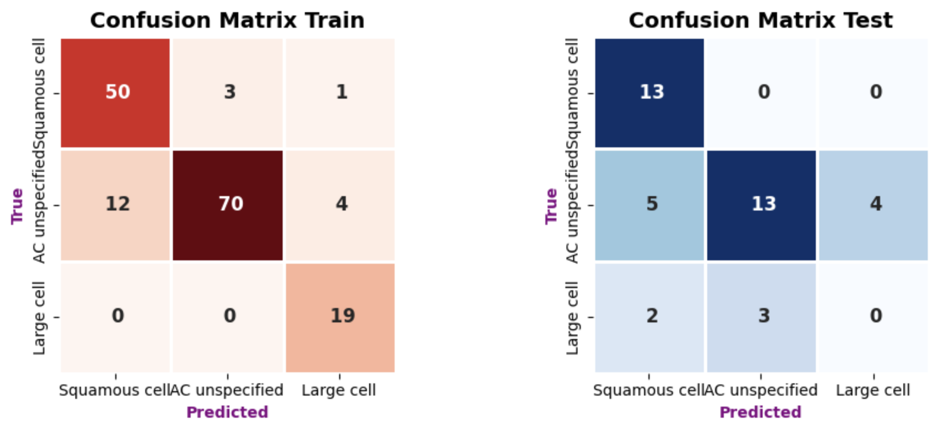

Train = 0.7, test = 0.3 (139,60)
# Define parameter grid
param_grid = {
'depth': [3, 4, 5],
'learning_rate': [0.01, 0.03, 0.05],
'l2_leaf_reg': [5, 7, 10],
'iterations': [100, 200, 300],
'bootstrap_type': ['Bernoulli'],
'subsample': [0.8, 1.0],
}

# Create model and GridSearchCV
# cb = CatBoostClassifier(random_state=42, verbose=0, class_weights=class_weights_dict)
cb = CatBoostClassifier(random_state=42, verbose=0)

# Use balanced accuracy as the evaluation metric
scorer = make_scorer(balanced_accuracy_score)

# Perform GridSearch with Stratified K-Fold Cross-Validation
kf = StratifiedKFold(n_splits=5, shuffle=True, random_state=42)

grid_search = GridSearchCV(
cb,
param_grid,
cv=kf,
scoring=scorer,
n_jobs=-1
)

# Fit GridSearchCV
grid_search.fit(X_train_res, y_train_res)

# Get best parameters and train final model
best_params = grid_search.best_params_
print("Best Parameters:", best_params)
Preprocessing | Hyper-params | Train_acc | Test_acc | Confusion matrix
- PCA(n_components=10), ratio = 0.924683  - SMOTE (random=42) | - Best Parameters: {'bootstrap_type': 'Bernoulli', 'depth': 5, 'iterations': 300, 'l2_leaf_reg': 7, 'learning_rate': 0.05, 'subsample': 0.8} | 0.9112 | 0.4485 | 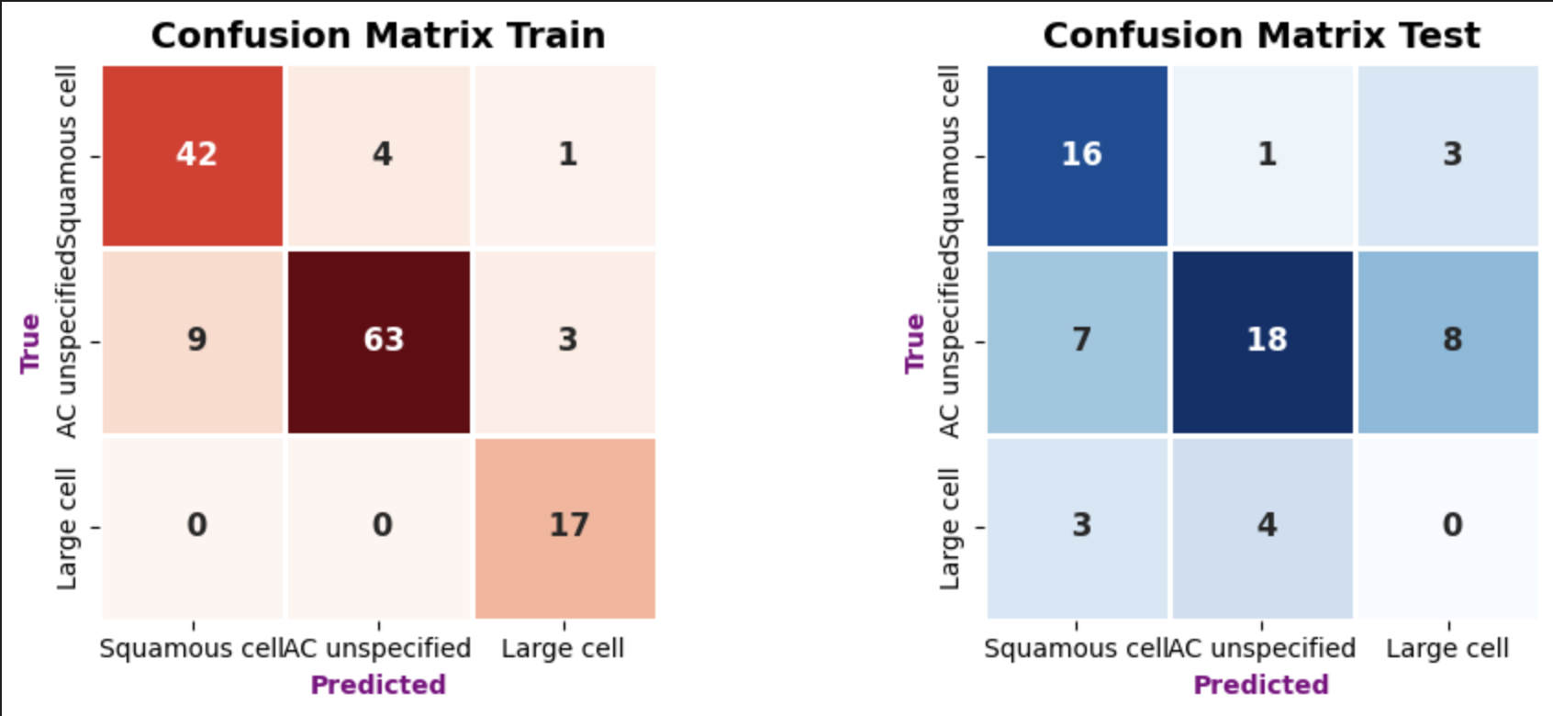

== version 1==
Train = 0.8 (159), test = 0.2 (40)
PCA:
- n_components = 0.9 (7 components)
- explained varience ratio = 0.90022053
train method:
# Define parameter grid
param_grid = {
'depth': [3, 4, 5],
'learning_rate': [0.01, 0.03, 0.05],
'l2_leaf_reg': [5, 7, 10],
'iterations': [100, 200, 300],
'bootstrap_type': ['MVS','Bayesian'],
'subsample': [0.8, 1.0],
}

# Create model and GridSearchCV
cb = CatBoostClassifier(random_state=42, verbose=0, class_weights=class_weights_dict)
# cb = CatBoostClassifier(random_state=42, verbose=0)

# Use balanced accuracy as the evaluation metric
scorer = make_scorer(balanced_accuracy_score)

# Perform GridSearch with Stratified K-Fold Cross-Validation
kf = StratifiedKFold(n_splits=5, shuffle=True, random_state=42)

grid_search = GridSearchCV(
cb,
param_grid,
cv=kf,
scoring=scorer,
n_jobs=-1
)

# Fit GridSearchCV
grid_search.fit(X_train_res, y_train_res) or grid_search.fit(X_train_pca, y_train)

# Get best parameters and train final model
best_params = grid_search.best_params_
print("Best Parameters:", best_params)

testing method:
# Train with best parameters
best_model = CatBoostClassifier(**best_params, random_state=42, verbose=0,
eval_metric='MultiClass',
early_stopping_rounds=20,
class_weights=class_weights_dict)
best_model.fit(X_train_pca, y_train, eval_set=(X_test_pca, y_test),plot=False)
# Accuracy
bal_acc_train = balanced_accuracy_score(y_train, y_pred_train)
bal_acc_test = balanced_accuracy_score(y_test, y_pred_test)

Preprocessing | Hyper-params | Train_acc | Test_acc | Confusion matrix
- PCA(n_components=7) | - Class weight  - Best Parameters: {'bootstrap_type': 'MVS', 'depth': 4, 'iterations': 100, 'l2_leaf_reg': 7, 'learning_rate': 0.01, 'subsample': 0.8} | 0.7574 | 0.5152 | 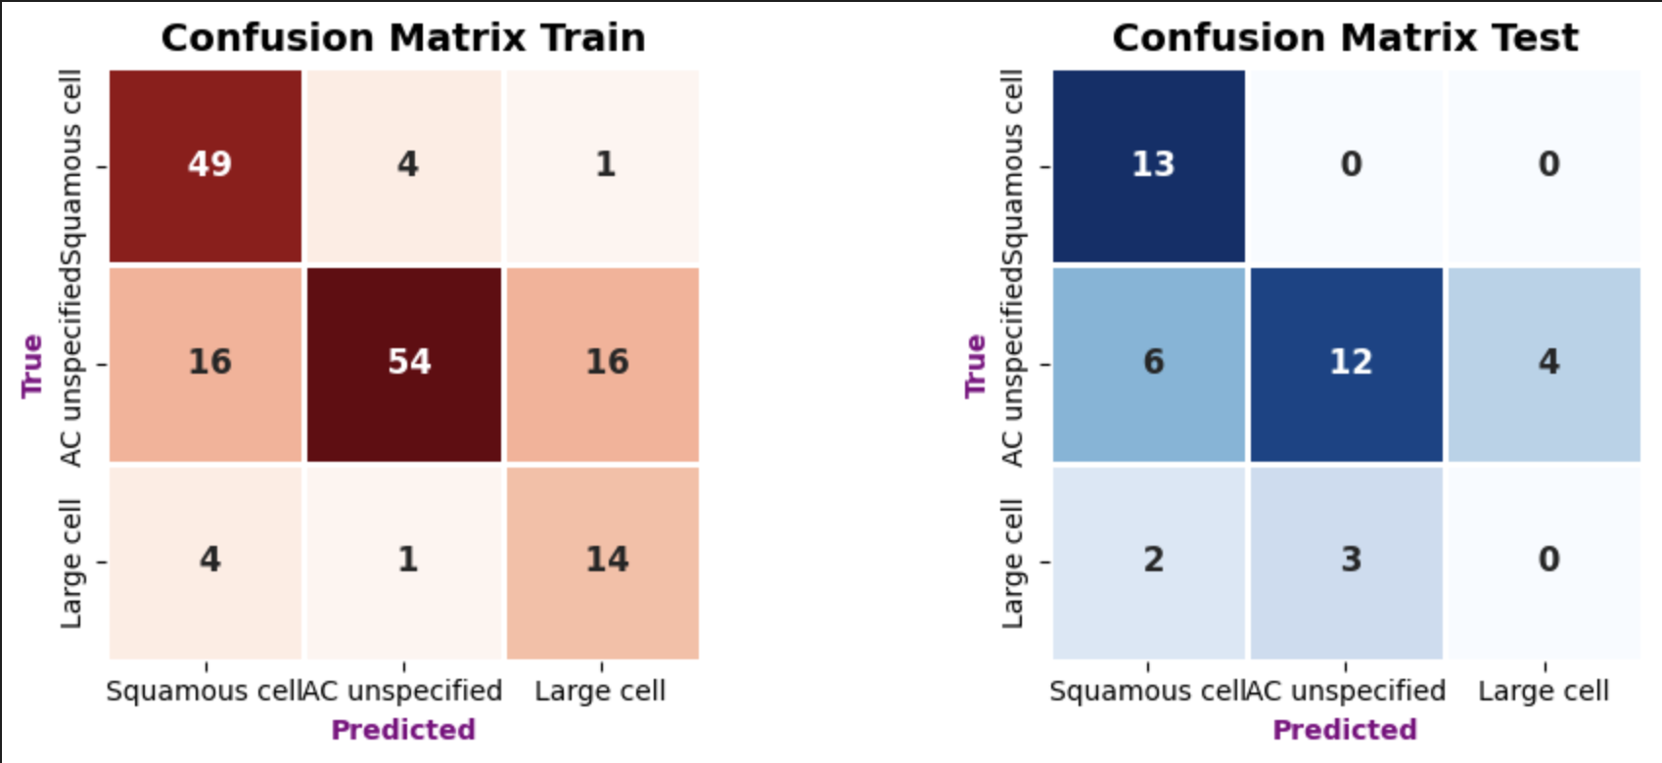
- PCA(n_components=7)  - SMOTE (random = 42) | - Best Parameters: {'bootstrap_type': 'MVS', 'depth': 5, 'iterations': 300, 'l2_leaf_reg': 5, 'learning_rate': 0.05, 'subsample': 1.0} | 0.6554 | 0.6061 | 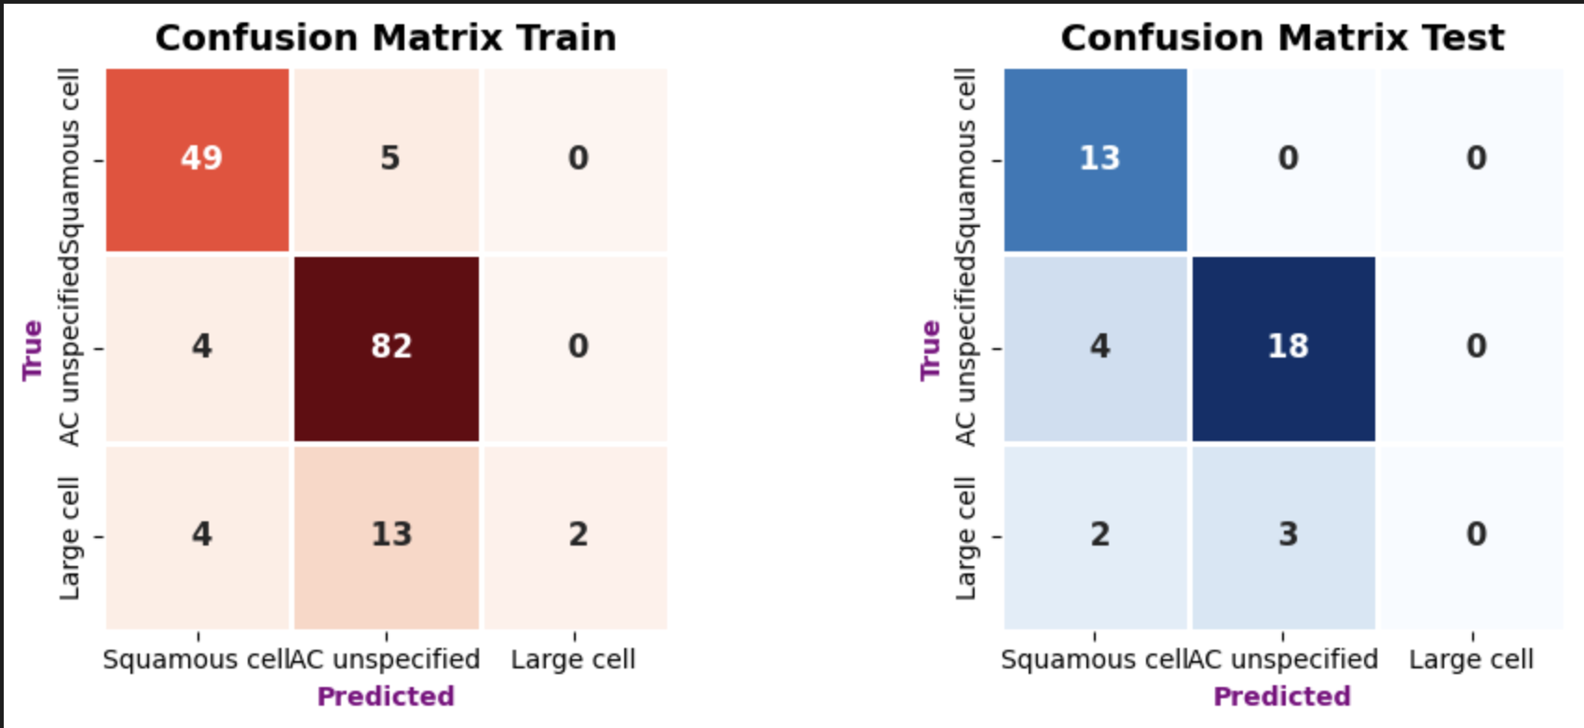
- PCA(n_components=7)  - Undersampling(random=42) | - Best Parameters: {'bootstrap_type': 'MVS', 'depth': 3, 'iterations': 100, 'l2_leaf_reg': 10, 'learning_rate': 0.03, 'subsample': 1.0} | 0.5886 | 0.5804 | 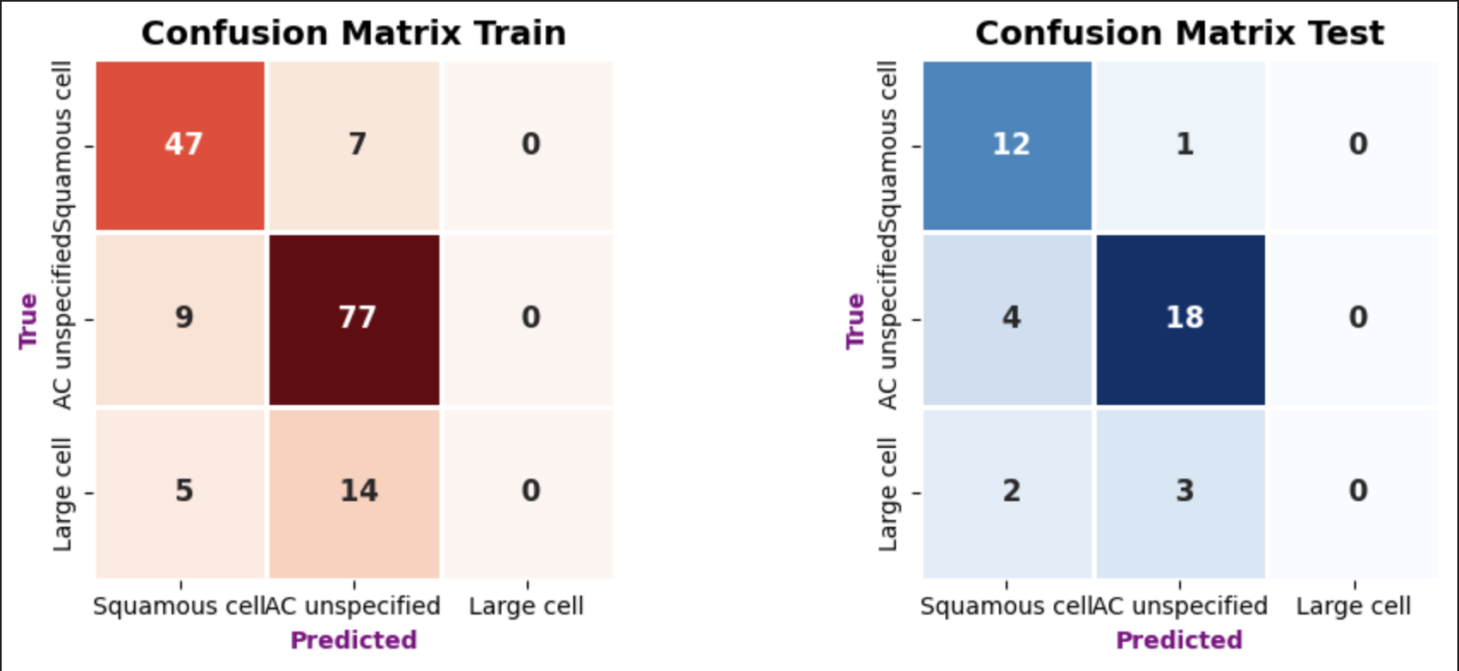

== t-SNE Experiment ==
tsne = TSNE(n_components=2, perplexity=30, n_iter=300)
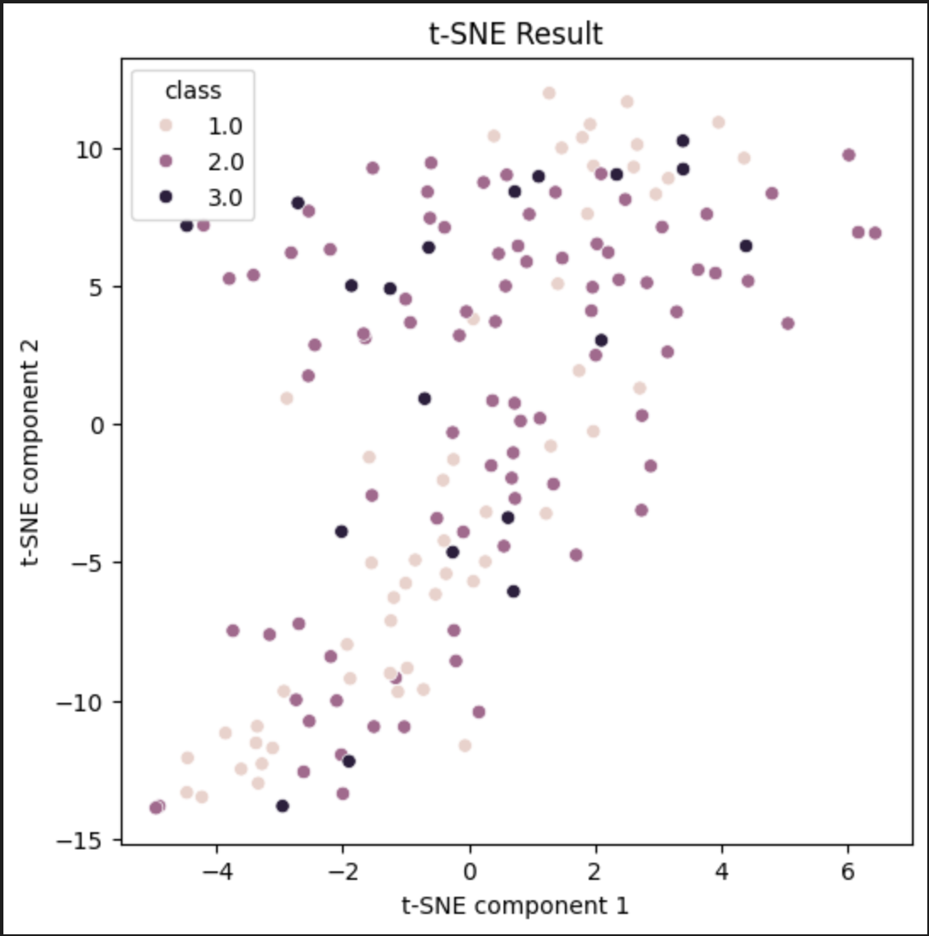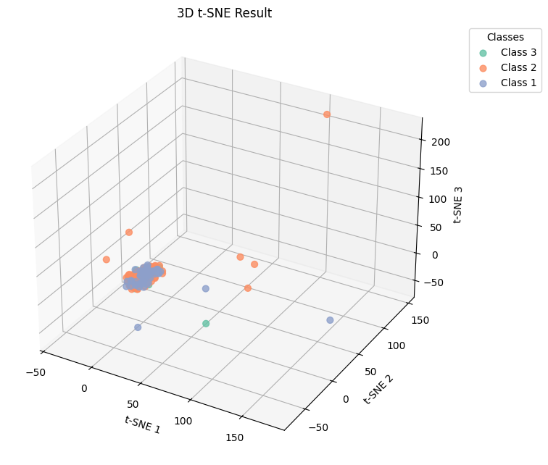
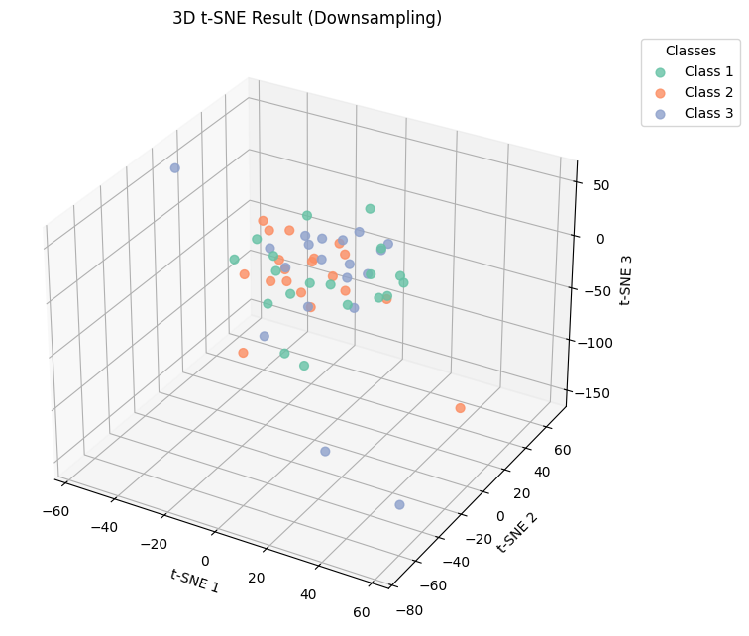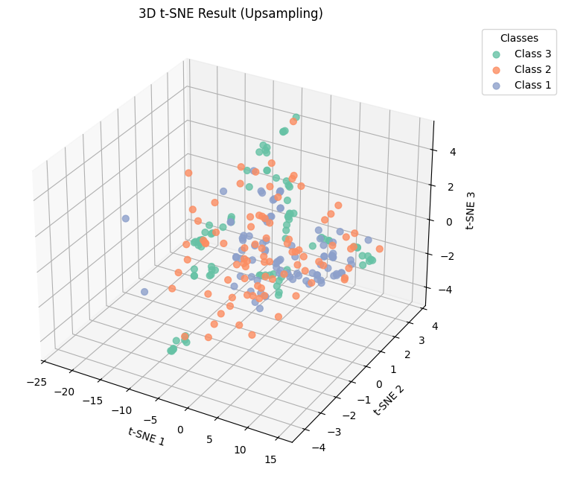

Preprocessing | Hyper-params | Train_acc | Test_acc | Confusion matrix
t-SNE (component = 2) | - Class weight  - Best Parameters: {'bootstrap_type': 'MVS', 'depth': 5, 'iterations': 200, 'l2_leaf_reg': 7, 'learning_rate': 0.01} | 0.5717 | 0.3333 | 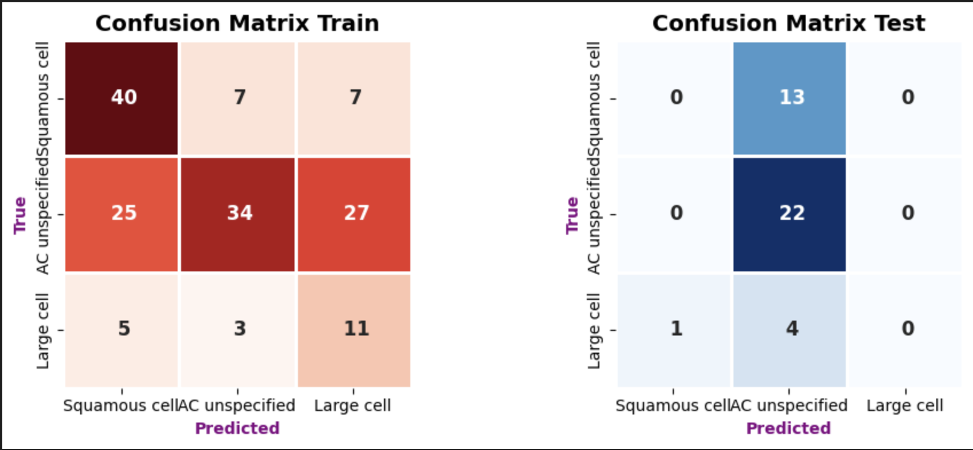
t-SNE (component = 3) | - Class weight  - Best Parameters:  {'bootstrap_type': 'Bayesian', 'depth': 5, 'iterations': 300, 'l2_leaf_reg': 5, 'learning_rate': 0.05} | 0.7169 | 0.3333 | 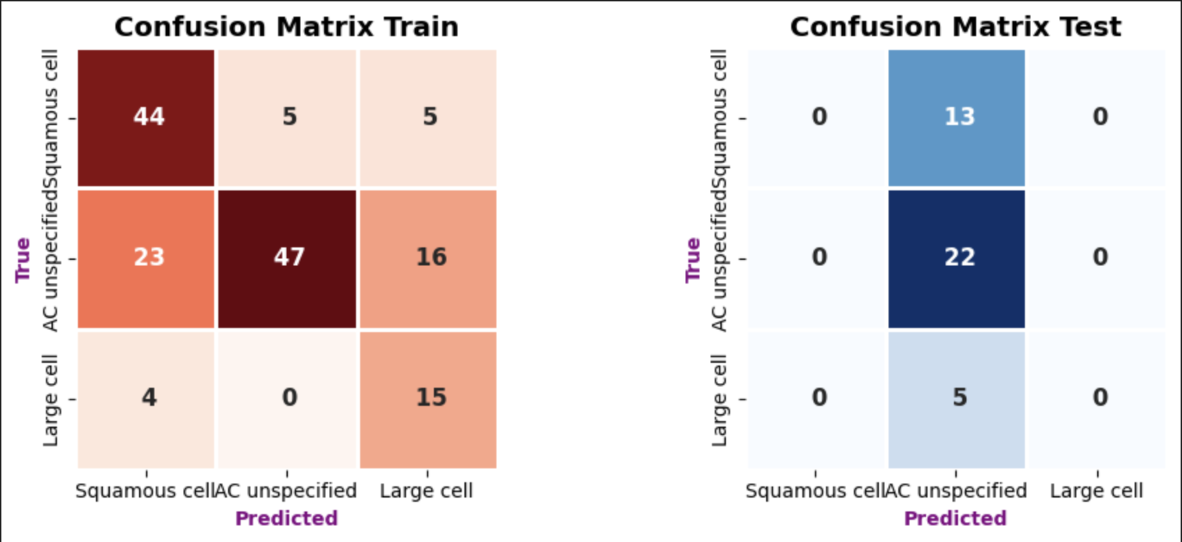
t-SNE (component = 3)  - Down sampling | Best Parameters: {'bootstrap_type': 'MVS', 'depth': 4, 'iterations': 300, 'l2_leaf_reg': 7, 'learning_rate': 0.05} | 0.8421 | 0.3030 | 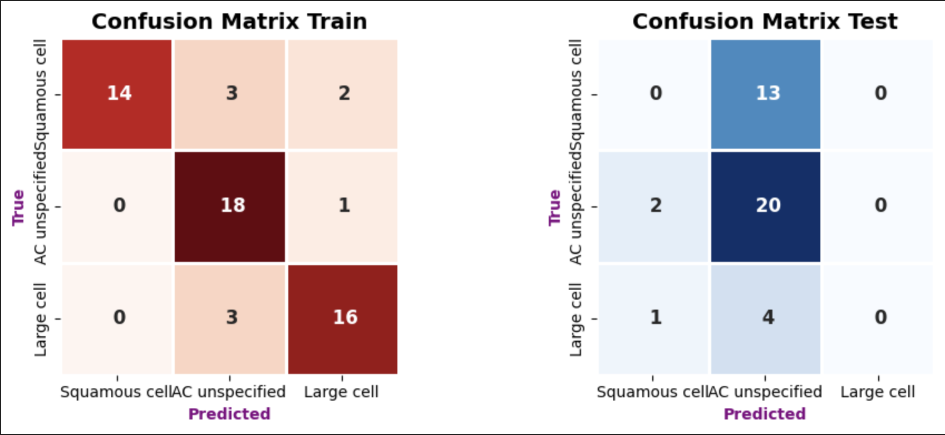
t-SNE (component = 3)  - Up sampling | Best Parameters: {'bootstrap_type': 'MVS', 'depth': 5, 'iterations': 300, 'l2_leaf_reg': 5, 'learning_rate': 0.05} | 0.6550 | 0.2667 | 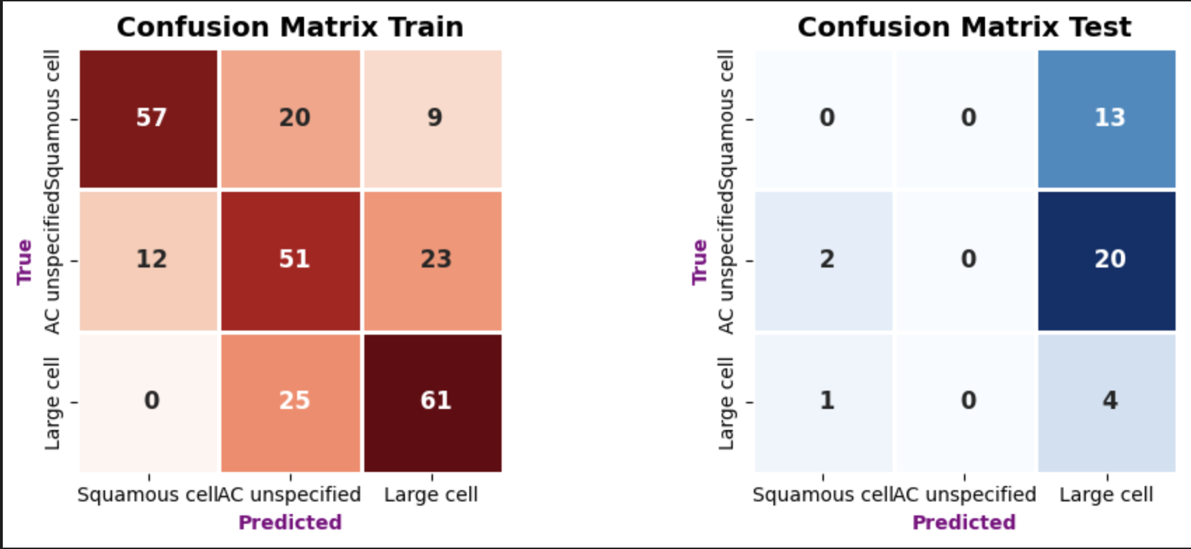

== UMAP Experiment ==
umap_model = umap.UMAP(n_neighbors=15, min_dist=0.1, n_components=2)
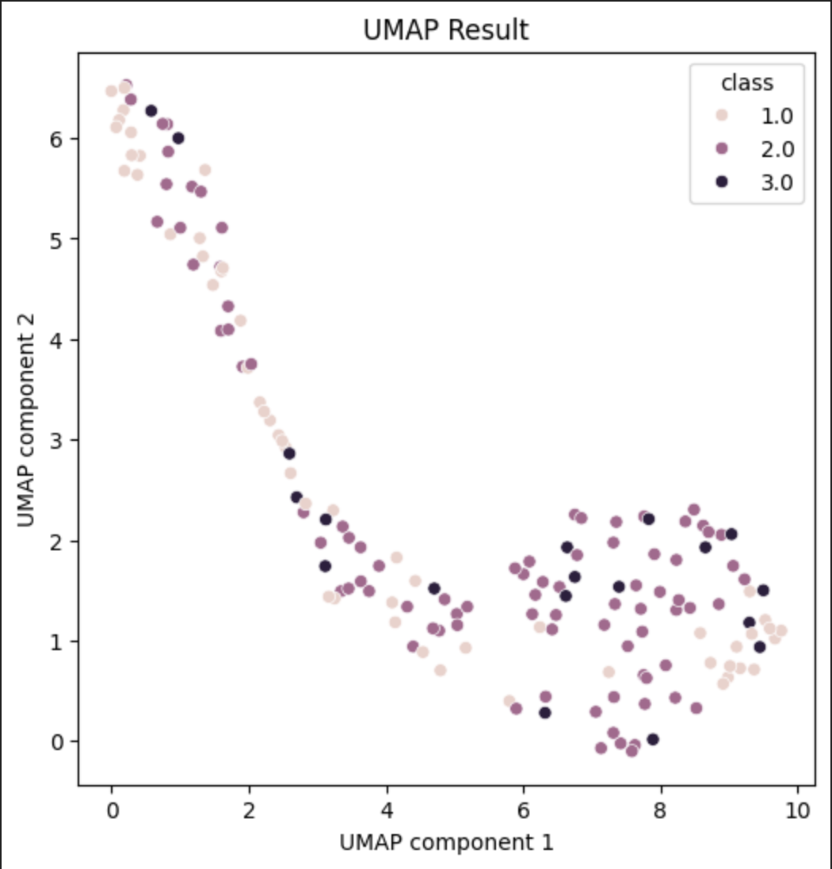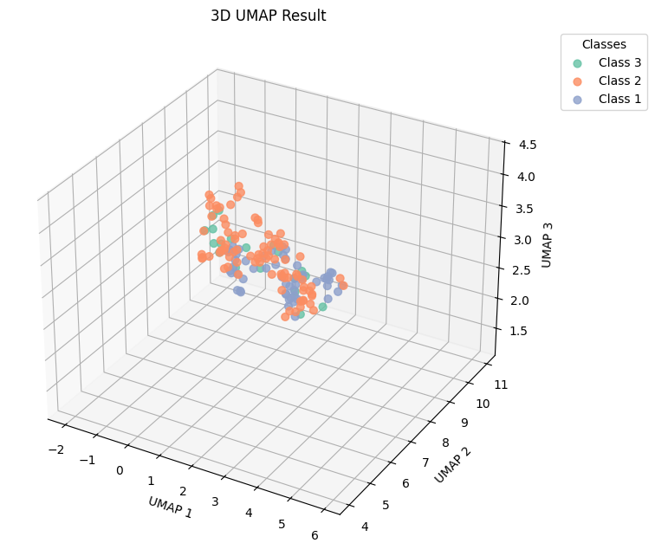
Preprocessing | Hyper-params | Train_acc | Test_acc | Confusion matrix
UMAP (component = 2) | - Class weight  - Best Parameters: {'bootstrap_type': 'MVS', 'depth': 5, 'iterations': 200, 'l2_leaf_reg': 7, 'learning_rate': 0.01} | 0.5872 | 0.4152 | 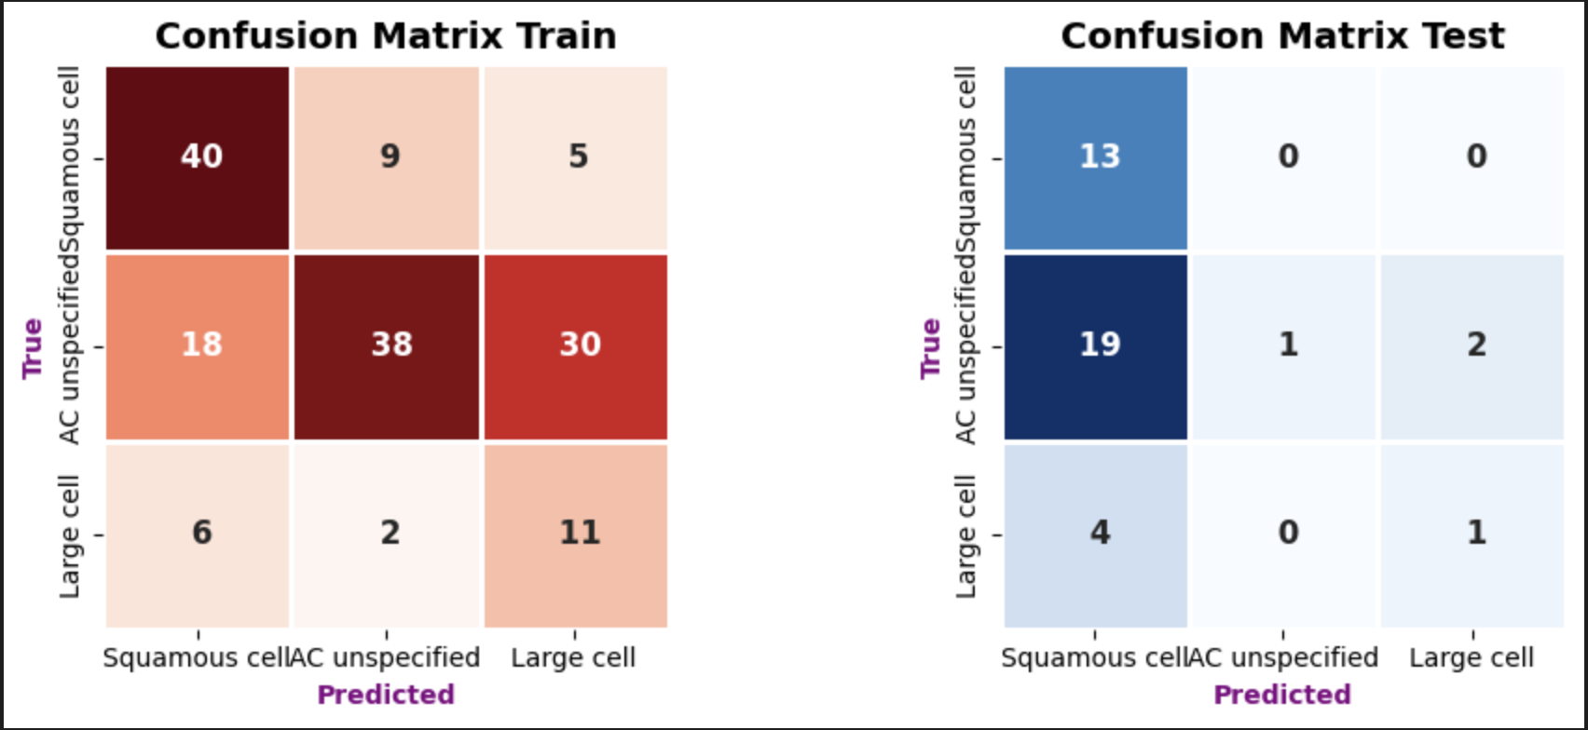
UMAP (component = 3) | - Class weight  - Best Parameters: {'bootstrap_type': 'Bayesian', 'depth': 4, 'iterations': 300, 'l2_leaf_reg': 5, 'learning_rate': 0.05} | 0.4873 | 0.3333 | 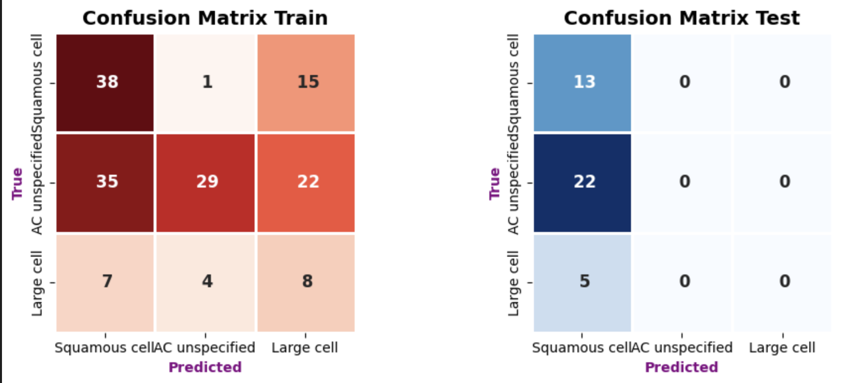

== PCA + UMAP ==
Best Params: {'catboost__depth': 4, 'catboost__learning_rate': 0.03, 'pca__n_components': 30, 'umap__min_dist': 0.5, 'umap__n_components': 10, 'umap__n_neighbors': 10}
Test Accuracy: 0.4172494172494172
Classification Report:
precision recall f1-score support

1 0.47 0.62 0.53 13
2 0.70 0.64 0.67 22
3 0.00 0.00 0.00 5

accuracy 0.55 40
macro avg 0.39 0.42 0.40 40
weighted avg 0.54 0.55 0.54 40

Best Params: {'catboost__depth': 6, 'catboost__learning_rate': 0.1, 'pca__n_components': 100, 'umap__min_dist': 0.5, 'umap__n_components': 10, 'umap__n_neighbors': 10}
Test Accuracy: 0.4233100233100233
Classification Report:
precision recall f1-score support

1 0.47 0.62 0.53 13
2 0.67 0.45 0.54 22
3 0.12 0.20 0.15 5

accuracy 0.47 40
macro avg 0.42 0.42 0.41 40
weighted avg 0.54 0.47 0.49 40

